# CS 255 System Design Document Template

This template lays out all the different sections that you need to complete for Project Two. Each section has guidance to prompt your thinking. You will need to continually reference the interview transcript as you work to make sure that you are addressing your client’s needs. There is no required length for the final document. Instead the goal is to complete each section based on what your client’s needs are. Remove this note when you are finished, and replace all bracketed text with the relevant information.

## UML Diagrams

### UML Use Case Diagram

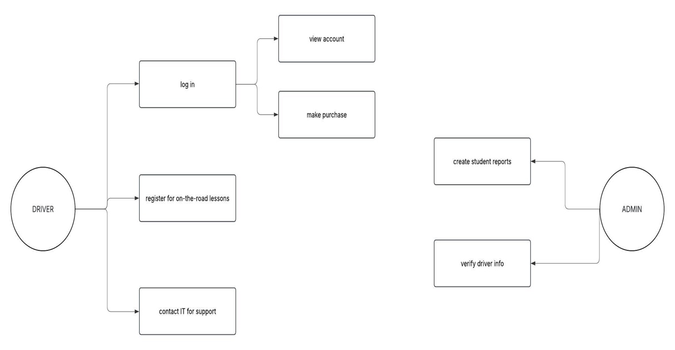

### UML Activity Diagrams

*Use Case 1: User Registration*

*Use Case 2: Reserving an On the Road Class*

### UML Sequence Diagram

### UML Class Diagram

## Technical Requirements

*The technical requirements of the DriverPass system should include a desktop or laptop (monitor) or some sort, a keyboard, & mouse. Also, a stable internet connection with appropriate cables and power source should be accessible. internet, cables, power source. Lastly, a proper OS, web browser, & the actual DriverPass system. These are some of the technical requirements (hardware, tools, software) necessary for the system design.*